**Name: Umugwaneza**

**Department: BIT**

**Level: 2**

**JAVA MISSED QUIZES**

**JAVA CONTROL STATEMENT:**

Java If-else Statement

Experiment 1

public class ndizeye {

public static void main(String[] args) {

//defining an 'age' variable

int age=45;

//checking the age

if(age>30){

System.out.print(" The Age is greater than 18");

}

}

}

SOLUTION;

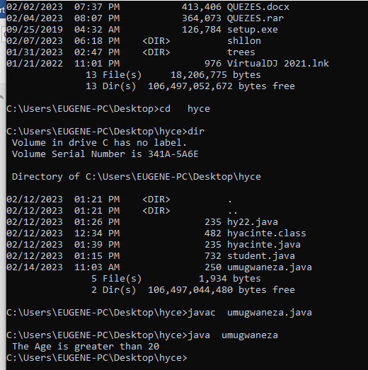

Experiment 2:

public class umugwaneza1 {

public static void main(String[] args) {

int number=13;

//Using ternary operator

String output=(number%2==0)?"even number":"odd number";

System.out.println(output);

}

}

**Out put:**

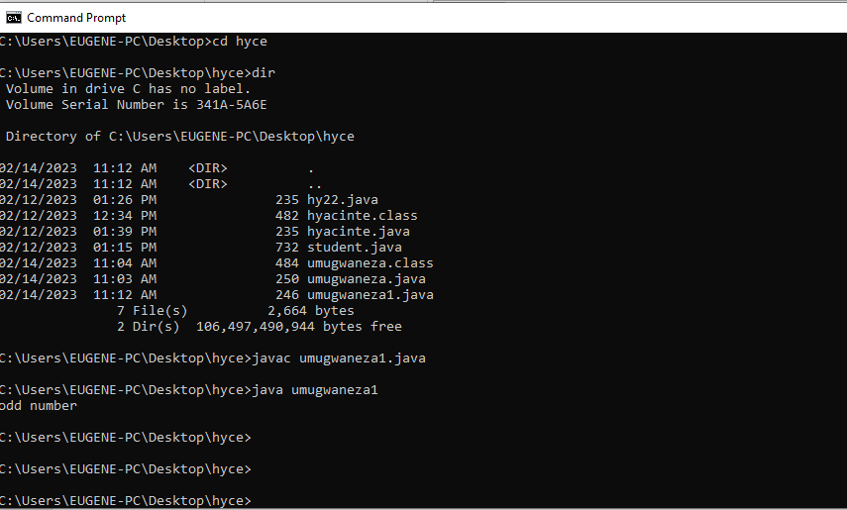

**EXPRIMENT 3.**

**public class Example2{**

**public static void main(String[] args) {**

**int marks=65;**

**if(marks<50){**

**System.out.println("fail");**

**}**

**else if(marks>=50 && marks<60){**

**System.out.println("D grade");**

**}**

**else if(marks>=60 && marks<70){**

**System.out.println("C grade");**

**}**

**else if(marks>=70 && marks<80){**

**System.out.println("B grade");**

**}**

**else if(marks>=80 && marks<90){**

**System.out.println("A grade");**

**}else if(marks>=90 && marks<100){**

**System.out.println("A+ grade");**

**}else{**

**System.out.println("Invalid!");**

**}**

**}**

**}**

**OUT PUT:**

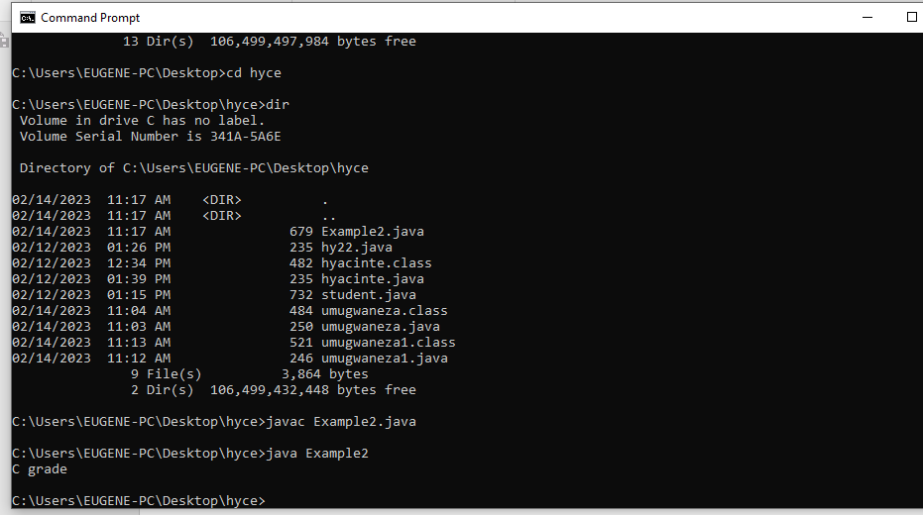

JAVA OBJECT CLASS:

EXPRIMENT 1:

**class Student{**

**int id;**

**String name;**

**}**

**class TestStudent3{**

**public static void main(String args[]){**

**Student s1=new Student();**

**Student s2=new Student();**

**s1.id=101;**

**s1.name="Sonoo";**

**s2.id=102;**

**s2.name="Amit";**

**System.out.println(s1.id+" "+s1.name);**

**System.out.println(s2.id+" "+s2.name);**

**}**

**}**

**OUT PUT:**

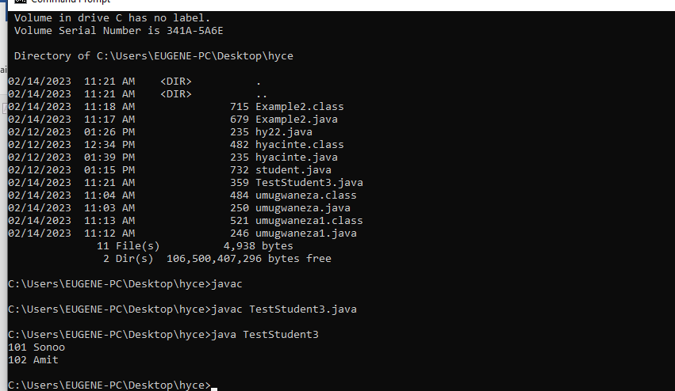

EXPRIMENT 2:

**class Rectangle{**

**int length;**

**int width;**

**void insert(int l, int w){**

**length=l;**

**width=w;**

**}**

**void calculateArea(){System.out.println(length*width);}**

**}**

**class Rectangle34{**

**public static void main(String args[]){**

**Rectangle r1=new Rectangle();**

**Rectangle r2=new Rectangle();**

**r1.insert(110,5);**

**r2.insert(300,15);**

**r1.calculateArea();**

**r2.calculateArea();**

**}**

**}**

**OUTPUT:**

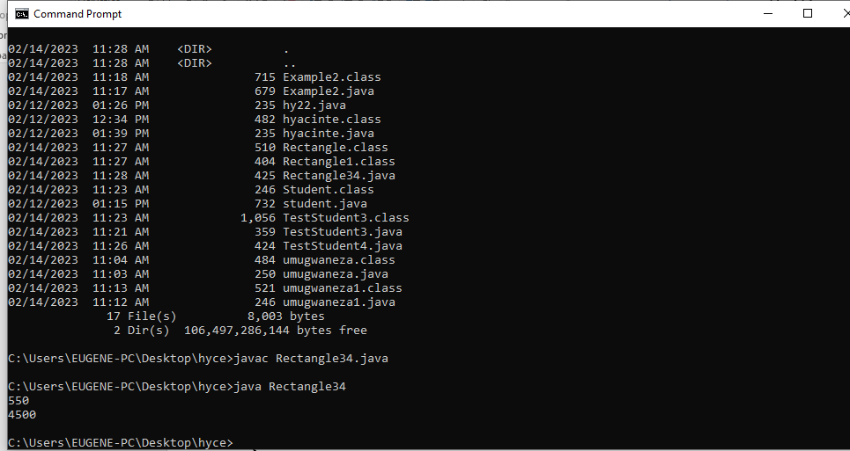

JAVA INHERTANCE:

Expriment 1;

class Employee{

float salary=4670000;

}

class Programmer extends Employee{

int bonus=1450000;

public static void main(String args[]){

Programmer p=new Programmer();

System.out.println("Programmer salary is:"+p.salary);

System.out.println("Bonus of Programmer is:"+p.bonus);

} }

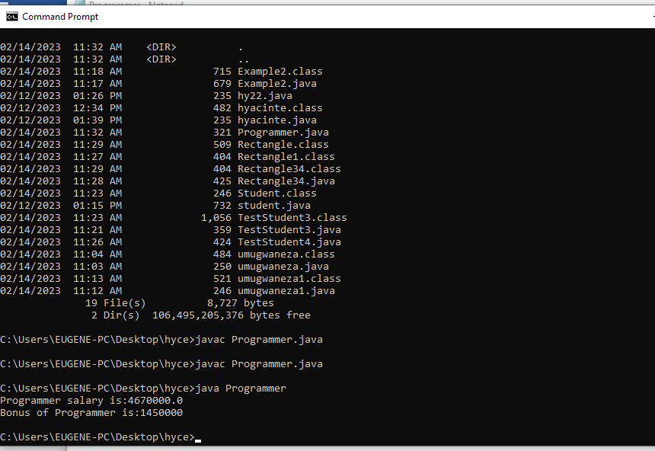

EXPRIMENT 2:

class Animal{

void eat(){System.out.println("MOVEMENT...");}

}

class Dog extends Animal{

void bark(){System.out.println("RUNNING...");}

}

class TestInheritance{

public static void main(String args[]){

Dog d=new Dog();

d.bark();

d.eat();

}}

OUT PUT:

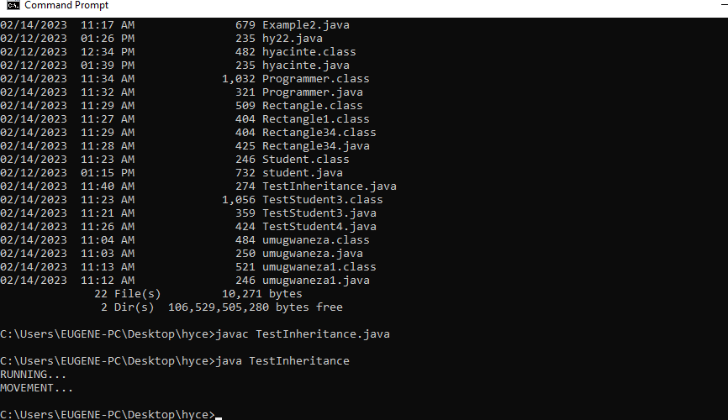

EXPRIMENT 3:

class Animal{

void eat(){System.out.println("eating ...");}

}

class Dog extends Animal{

void bark(){System.out.println("barking...");}

}

class Cat extends Animal{

void meow(){System.out.println("meowing ...");}

}

class TestInheritance3{

public static void main(String args[]){

Cat c=new Cat();

c.meow();

c.eat();

//c.bark();//C.T.Error

}}

OUT PUT:

